UNIT-V

MEASUREMENT OF RESISTANCE

**5.1. Classification of resistance**

* Low resistance is the range of 0.1ohm to 1 ohm.
* Medium resistance is the range of 1 ohm to low mega ohm.
* High resistance is 0.1 mega ohm to a higher range.

**5.1.1. Methods for the measurement of low resistance**

* Kelvin double bridge
* Ammeter – voltmeter method

**5.1.2. Methods for the measurement of medium resistance**

* Ammeter – voltmeter method
* Wheat stone bridge method
* Ohm meter method

**5.1.3. Methods for the measurement of high resistance**

* Direct deflection methods
* Loss of charge methods
* Mega ohm bridge method

5.2. Voltmeter- Ammeter Method:

Procedure:

This method is used for measurement of medium resistances. This method is very popular since the instruments required for this test are usually available in the laboratory. Two types of connections employed for an ammeter-voltmeter method are shown in fig.1 and fig.2. In both the cases, if readings of ammeter and voltmeter are taken, then the measured value of resistance is given by:

R_m=frac{Voltmeter readings}{Ammeter Readings}=frac{V}{I}

The measured value of resistance Rm,would be equal to the true value, R, if the ammeter resistance is zero and the voltmeter resistance is infinite, so that the conditions in the circuit are not disturbed. But in practice this is not possible and ,hence both the methods give inaccurate results.

Considering the circuit:

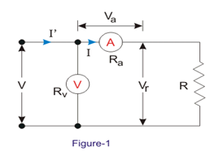

In this circuit ammeter measures the true value of the current through the resistance but the voltmeter does not measure the true voltage across the resistance. The voltmeter indicates the sum of the voltages across the ammeter and the measured resistance.

Let Ra be the resistance of the ammeter.

So the voltage across the ammeter = V_a=IR_a

Now, measured value of resistance,

R_{m1} = frac{V}{I}=frac{(V_R+V_a)}{I}=frac{(IR+IR_a)}{I} = R + R_a

So the value of resistance,

R = R_{m1 }-R_a=R_{m1 } (1-frac{R_a}{R_{m1 }})

Thus the measured value of resistance is higher than the true value. It is also clear from above that true value is equal to the measured only if the ammeter resistance ,R\_a is zero.

Relative error,    epsilon_r= frac{(R_{m1}-R)}{R}= frac{R_a}{R}

The relative error would be small if the value of resistance under measurement is large as compared to the internal resistance of the ammeter. Therefore, the  circuit in fig.1 is suitable for measuring high resistance values.

Considering the circuit :

**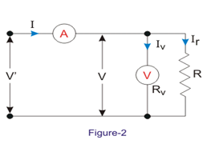**

in this circuit the voltmeter measures the true value of voltage but the ammeter measures the sum of currents through the resistance and the voltmeter. So, the current through the voltmeter,

I_v=frac{V}{I_v}

Measured value of resistance,

R_{m2 }= frac{V}{I} =frac{V}{(IR+IV)} =frac{V}{(frac{V}{R}+frac{V}{R_v})} = frac{R}{(1+frac{R}{R_V})}

True value of resistance,

R =\frac{R_{m2} Rv}{R_v-{R_{m2}}} =R_{m2}(\frac{1}{1-\frac{R_{m2}}{R_v}})

It is clear that the true value of resistance is equal to the measured value only if the resistance of voltmeter, R\_v, is infinite. However , if the resistance of voltmeter is very large as compared to the resistance under measurement :

Rv >>Rm2 , and therefore, Rm2/Rv is very small.

Thus, we have,

                     R = Rm2(1 + Rm2/Rv)

Thus the measured value of resistance is smaller than the true value.

Relative error,

\epsilon _r=\frac{R_{m2}-R}{R_v}=\frac{R_{m2}^2}{R_vR}

The value of Rm2 is approximately equal to R.

Relative error,

\epsilon _r=\frac{-R}{R_v}

The relative error for the two cases are equal when:  Ra/R = R/Rv

Or, when true value of resistance,

R=\sqrt{R_aR_v}

# 5.3. Wheatstone Bridge:

**Wheatstone bridge** is a very important device used in the measurement of medium [resistances](http://www.electricalengineeringinfo.com/2014/01/what-is-resistor-resistance-and-units-colour-coding.html) .A Wheatstone bridge has been in use longer than almost, any [electrical measuring instrumen](http://www.electricalengineeringinfo.com/2016/03/types-electrical-measuring-instruments-absolute-secondary-instruments.html)t. It is still an accurate and reliable instrument and is extensively used in industry. **Wheatstone bridge** is an instrument for making comparison measurements and operates upon a null indication principle. This means the indication is independent of the calibration of the null indicating instrument or any of its characteristics. For this reason, very high degrees of accuracy can be achieved using Wheatstone bridge. The [accuracy](http://www.electricalengineeringinfo.com/2016/03/static-characteristics-and-dynamic-characteristics-of-electrical-measuring-instruments.html) of 0.1%  is quite common with a **Wheatstone bridge** as opposed to accuracies of 3% to 5% with the ordinary ohmmeter for measurement of medium resistances.   
           The figure below shows the basic circuit of a **Wheatstone bridge**. It has four resistive arms, consisting of [resistances](http://www.electricalengineeringinfo.com/2014/01/what-is-resistor-resistance-and-units-colour-coding.html) P, Q R and S together with a source of emf (a battery) and a null detector, usually a galvanometer G or other sensitive current meter. The current through the galvanometer depends on the [potential difference](http://www.electricalengineeringinfo.com/2016/02/what-is-voltage-or-electric-potential-difference-defination.html) between points b and d. The bridge is said to be balanced when there is no current through the galvanometer or when the potential difference across galvanometer is zero. This occurs when the voltage from point b to point a equals the voltage from point d to point a or by referring to the other battery terminal, when the voltage from point d to point c equals the [voltage](http://www.electricalengineeringinfo.com/2016/02/what-is-voltage-or-electric-potential-difference-defination.html) from point b to point c.   
For balanced condition, we can write,

I1 P=I2R  
the figure below shows the circuit for *Wheatstone bridge* for the **measurement of medium resistance.**

[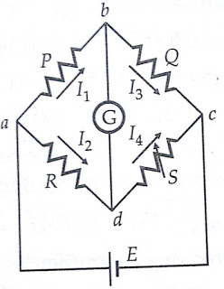](https://3.bp.blogspot.com/-X9ogUzizLmo/WBsy4Z1ymsI/AAAAAAAAI58/A02Zzt2dxosp2SbS1MkIwjWezZf7dGZWACLcB/s1600/measurement-medium-resistance-wheatstone-bridge.jpg)

Fig.3

For the galvanometer current to be zero, the following conditions also exist:

[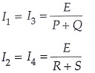](https://4.bp.blogspot.com/-KVx-Dtcc9to/WBtHraHWrZI/AAAAAAAAI98/cV3Rb-j864gtHywucLcpCkjtD5-MMXdcQCLcB/s1600/measuring-of-medium-resistance-wheatstone-bridge-7.jpg)

where  E=emf of the battery  
  
Combining above three equations we get ,

[measurement-of-medium-resistance-wheatstone-bridge , sensitivity-of-wheatstone-bridge](https://1.bp.blogspot.com/-ESdJS9Dbd98/WBtHskin6tI/AAAAAAAAI-A/E68bHotAiGAC-SIZqRHm9koReCGn0TizQCLcB/s1600/measuring-of-medium-resistance-wheatstone-bridge-8.jpg)

From which                     
                                       Q.R = P.S    ---> (1)

Equation-1 is the well-known expression for the balance of **Wheatstone bridge**. If three of the [resistances](http://www.electricalengineeringinfo.com/2014/01/what-is-resistor-resistance-and-units-colour-coding.html) are known, the fourth may be determined from equation-1 and we obtain

                                    R = S\*(P/Q)

Where R is the unknown [resistance](http://www.electricalengineeringinfo.com/2014/01/what-is-resistor-resistance-and-units-colour-coding.html), S is called the ‘standard arm' of the bridge and P and Q are called the 'ratio arms'.

                 In the industrial and laboratory form of the bridge, the resistors which make up P, Q and S are mounted together in a box, the appropriate values being selected by dial switches. Battery and galvanometer switches are included together with a galvanometer and dry battery in the portable sets. P and Q normally consist of four resistors each, the values being 10,100,1000 and 10,000Ω respectively S that decade arrangement of resistors. The below figure shows the commercial form of *Wheatstone bridge* for the **measurement of medium resistance.**

**[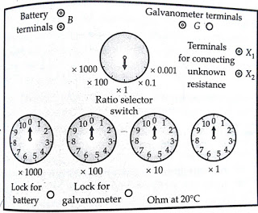](https://4.bp.blogspot.com/-QjhrcxPLUG0/WBszQ2Lsp2I/AAAAAAAAI6A/kqChxew1h7oLBvu6xa711XxM90NXpzwFwCLcB/s1600/measurement-of-medium-resistance-wheatstone-bridge.jpg)**

Fig.4

### Sensitivity of Wheatstone bridge:

         It is frequently desirable to know the galvanometer response to be expected in a bridge which is slightly unbalanced so that a current flows in the galvanometer branch of the bridge network.The [sensitivity](http://www.electricalengineeringinfo.com/2016/03/static-characteristics-and-dynamic-characteristics-of-electrical-measuring-instruments.html) to unbalance can be computed by solving the bridge circuit for a small unbalance. The solution is approached by converting the **Wheatstone bridge** of figure above to its "Thevenin Equivalent" circuit. Assume that the bridge is balanced when the branch [resistances](http://www.electricalengineeringinfo.com/2014/01/what-is-resistor-resistance-and-units-colour-coding.html) are P, Q, R, S so that P / Q = R / S. Suppose the resistance R is changed to R+ΔR creating an unbalance. This will cause an emf 'e' to appear across the galvanometer branch. With galvanometer branch open, the [voltage](http://www.electricalengineeringinfo.com/2016/02/what-is-voltage-or-electric-potential-difference-defination.html) drop between points a and b is :

[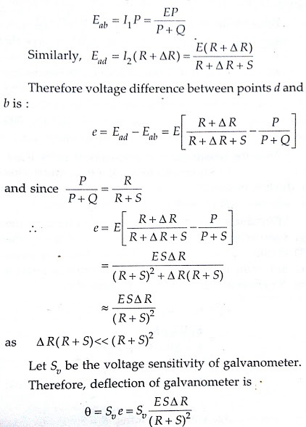](https://3.bp.blogspot.com/-_zWnkN5ukUk/WBtBzTg04XI/AAAAAAAAI9U/xI6ReBARNuEfEBvAJ1-NKs7WJfUVfAQeACLcB/s1600/measureming-medium-resistance-wheatstone-bridge.jpg)

The bridge [sensitivity](http://www.electricalengineeringinfo.com/2016/03/static-characteristics-and-dynamic-characteristics-of-electrical-measuring-instruments.html) is defined as the deflection of the galvanometer per unit fractional change in unknown [resistance](http://www.electricalengineeringinfo.com/2014/01/what-is-resistor-resistance-and-units-colour-coding.html).  
**Sensitivity of Wheatstone bridge:**  
[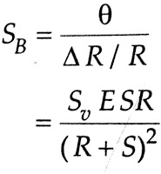](https://1.bp.blogspot.com/-RtPUD9CrydE/WBs2_u8JL4I/AAAAAAAAI7Q/_z1S1QyIDD0pGthdBWKVQs1LvvlQdfgKgCLcB/s1600/measuring-medium-resistance-wheatstone-bridge.jpg)

           From the above equation, it is clear that the **sensitivity  of Wheatstone bridge** is dependent upon bridge [voltage](http://www.electricalengineeringinfo.com/2016/02/what-is-voltage-or-electric-potential-difference-defination.html), bridge parameters and the voltage [sensitivity](http://www.electricalengineeringinfo.com/2016/03/static-characteristics-and-dynamic-characteristics-of-electrical-measuring-instruments.html) of the galvanometer. Rearranging the terms in the expression for sensitivity,

[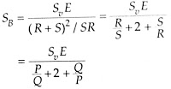](https://3.bp.blogspot.com/-ocUQRjAD5LI/WBs6dnPjZiI/AAAAAAAAI70/NtZPxZSfGbYAYqpjuwfXeLXVXrqUfQFjwCLcB/s1600/measuring-of-medium-resistance-wheatstone-bridge.jpg)

          From the above equation , it is apparent that maximum sensitivity occurs where R / S = 1.As the ratio becomes either larger or smaller, the sensitivity decreases. Since the accuracy of measurement is dependent upon sensitivity a limit can be seen to the usefulness for a given bridge, battery and galvanometer combination.  For a bridge with equal arms, R=S=P=Q.

Bridge sensitivity , SB= (SV.E)/4  
  
          As explained above the **sensitivity of Wheatstone bridge** is maximum when the ratio is unity.

The sensitivity decreases considerably if the ratio P / Q = R / S is greater or smaller than unity. This reduction in [sensitivity](http://www.electricalengineeringinfo.com/2016/03/static-characteristics-and-dynamic-characteristics-of-electrical-measuring-instruments.html) is accompanied by a reduction in accuracy with which a bridge can be balanced.

#### Galvanometer Current:

The current through the galvanometer can be found out by finding the Thevenin equivalent circuit. The Thevenin or open circuit [voltage](http://www.electricalengineeringinfo.com/2016/02/what-is-voltage-or-electric-potential-difference-defination.html) appearing between terminals b and d with galvanometer circuit open circuited is,

[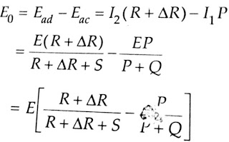](https://1.bp.blogspot.com/-By1tmX6rs5E/WBs8tt9lYbI/AAAAAAAAI8g/BKLWX3HdMKMBTY4ks9j2Fsum4KEHhzKxACLcB/s1600/measuring-of-medium-resistance-wheatstone-bridge-1.jpg)

[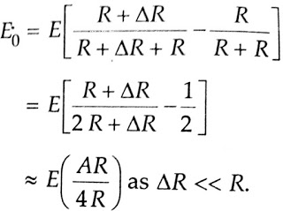](https://3.bp.blogspot.com/-Lcmh9pVl7vQ/WBs8v4qSxWI/AAAAAAAAI8k/aV-6kbruqeYvgNcmDDmbcHUOF5iqwQg7gCLcB/s1600/measuring-of-medium-resistance-wheatstone-bridge-2.jpg)

The resistance of the Thevenin equivalent circuit is found by looking back into terminal b and d and replacing the battery by its internal resistance. In most cases, however, the extremely low [resistance](http://www.electricalengineeringinfo.com/2014/01/what-is-resistor-resistance-and-units-colour-coding.html) of the battery can be neglected and this simplifies the solution as we can assume that terminals a and c are shorted. The Thevenin equivalent resistance can be calculated by referring to the below figure.

[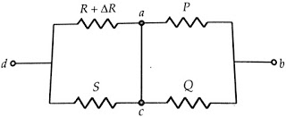](https://3.bp.blogspot.com/-TH5oW5IKm3U/WBs_X6ME_rI/AAAAAAAAI84/fBk4fsg6zTgA3lSI12bEyM4uR6gPriqdgCLcB/s1600/measuring-of-medium-resistance-wheatstone-bridge-3.jpg)

Fig.5

Thevenin equivalent resistance of bridge ,

[measurement-of-medium-resistance-wheatstone-bridge , sensitivity-of-wheatstone-bridge](https://4.bp.blogspot.com/--P_7aj6Lr5Y/WBtA4png-mI/AAAAAAAAI9M/eyFyEKpqyXUbI-hGScHaqic4-ZoWUZeVACLcB/s1600/measuring-of-medium-resistance-wheatstone-bridge-6.jpg)

For a bridge with equal arms,   
  
                              P = Q = S = R   
                           
                               R0= R   
  
          The Thevenin equivalent of the bridge circuit, therefore, reduces to a Thevenin generator with an [emf](http://www.electricalengineeringinfo.com/2016/02/what-is-voltage-or-electric-potential-difference-defination.html) E0  and an internal [resistance](http://www.electricalengineeringinfo.com/2014/01/what-is-resistor-resistance-and-units-colour-coding.html) R0.Thevenin equivalent circuit of Wheatstone Bridge is shown below.

[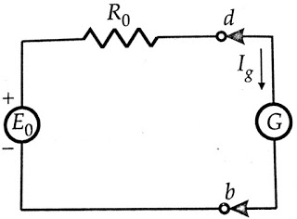](https://3.bp.blogspot.com/-XBTt_4QPT3c/WBs_Z673CoI/AAAAAAAAI9I/PeUwYJQUHr0JrLPivoh9Mt67iha7G_kIwCEw/s1600/measuring-of-medium-resistance-wheatstone-bridge-4.jpg)

Fig.6

The current in the galvanometer circuit ,  
                                Ig = E0/(R0 + G)  
Where G = [resistance](http://www.electricalengineeringinfo.com/2014/01/what-is-resistor-resistance-and-units-colour-coding.html) of the galvanometer circuit,

[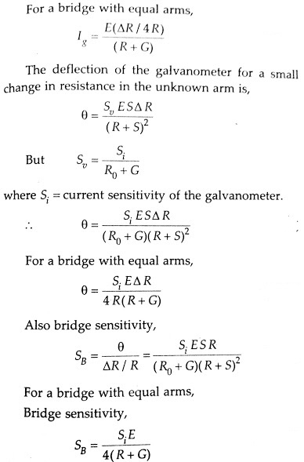](https://1.bp.blogspot.com/-DYpChfOl9r8/WBtB_BW22GI/AAAAAAAAI9Y/_qLQ71fmhjs8w7d3olrXMv9d1hfkjvboACEw/s1600/measuring-of-medium-resistance-wheatstone-bridge-5.jpg)

**5.4. Kelvin Double bridge for Low Resistance Measurement:**

                The **Kelvin double bridge** method described above is obviously not a practical way of achieving the desired, result, as there would certainly be a trouble in determining the correct point for galvanometer connections. So the simple modification is that two actual resistance units of character ratio be connected between points m and n, the galvanometer be connected to the junction of the resistors. This is the actual **kelvin bridge arrangement** which is shown below.   
              The **Kelvin double bridge** incorporates the idea of a second set of ratio arms - hence the name double bridge has come and the use of four terminal resistors for low [resistance](http://www.electricalengineeringinfo.com/2014/01/what-is-resistor-resistance-and-units-colour-coding.html) arms. Below figure shows the schematic diagram of **kelvin double bridge**. The second set of ratio arms p and q is used to connect the galvanometer to a point d at the appropriate potential between points m and n to eliminate the effect of connecting lead of resistance r between the known resistance R and the standard resistance S. 

|  |
| --- |
|  |
| **Fig.7.Kelvin Double Bridge Method** for Low Resistance Measurement |

The ratio p/q is made equal to P/Q . Under balanced conditions, there is no current through the galvanometer, which means that the [voltage](http://www.electricalengineeringinfo.com/2016/02/what-is-voltage-or-electric-potential-difference-defination.html) drop between a and b, Eab is equal to the voltage drop Eamd between a and c.   
                                          
          Now,

[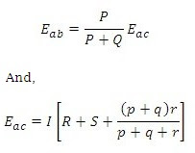](https://4.bp.blogspot.com/-dinnv6lr0yw/V_FWMU8WE3I/AAAAAAAAIhk/PoSurf55cLgpc6olhmuWUes96B8e9ijEQCEw/s1600/kelvin-bridge-circuit-formula.jpg)

[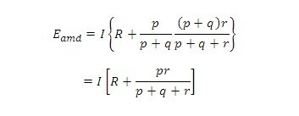](https://3.bp.blogspot.com/-DC9EDAaVJz0/V_FWNZQfLhI/AAAAAAAAIiA/L2YRgOR_C3wZNlScTzKBtWjqQyr1hRu-QCEw/s1600/kelvin-bridge-circuit-formulas.jpg)

For zero galvanometer deflection,   
                 Eab  =   Eamd 

[Kelvin Double Bridge Method for Low Resistance Measurement](https://3.bp.blogspot.com/-1E571yasYDQ/V_FWL0LNwMI/AAAAAAAAIhc/2_Dg9fe3Rwc8fralpr9c8Zdmp6XNxTWuACEw/s1600/Kelvin-Double-Bridge-Circuit-formula.jpg)

[Kelvin Double Bridge Method for Low Resistance Measurement](https://2.bp.blogspot.com/-FKlgoAgkf5E/V_FWL3WDvVI/AAAAAAAAIhg/IPMkxNPCHkkRCXOe1D4IvNwAxfoVIIhxACEw/s1600/Kelvin-Double-Bridge-Circuit-formula+-+Copy.jpg)  eqn.1

Now if P/Q = p/q , equation above becomes

[Kelvin Double Bridge Method](https://2.bp.blogspot.com/-mZppUKRIpC0/V_FWL4hhd3I/AAAAAAAAIhY/RIDJ1OAv4W04BckGu_5woILetM_JzBT9wCEw/s1600/Kelvin-Double-Bridge-Circuit-formula+-+Copy+(2).jpg)               eqn.2

Equation 2 to is the usual working equation for **Kelvin Bridge circuit**. It indicates that the [resistance](http://www.electricalengineeringinfo.com/2014/01/what-is-resistor-resistance-and-units-colour-coding.html) of connecting lead 'r' has no effect on the measurement, provided that the two sets of ratio arms have equal ratios. Equation 1, however, as it shows the error that is introduced in case the ratios are not exactly Ω equal. It indicates that it is desirable to keep r as small as possible in order to minimise the errors in case there is a difference between ratios P/Q and p/q.   
     The effect of thermoelectric [emf](http://www.electricalengineeringinfo.com/2016/02/what-is-voltage-or-electric-potential-difference-defination.html)'s can be eliminated by making another measurement with the battery connections reversed. The true value of R being the mean of the two readings.

5.5.Loss of Charge method:

            In '**Loss of charge method**' the insulation [resistance](http://www.electricalengineeringinfo.com/2014/01/what-is-resistor-resistance-and-units-colour-coding.html) R to be measured is connected in parallel with a capacitor C and an electrostatic voltmeter. The capacitor is charged to some suitable [voltage](http://www.electricalengineeringinfo.com/2016/02/what-is-voltage-or-electric-potential-difference-defination.html), by means of a battery having voltage V and is then allowed to discharge through the resistance. The terminal voltage is observed over a considerable period of time during discharge.

[](https://1.bp.blogspot.com/-lLPa0Zt6NA8/WBR_AW7m86I/AAAAAAAAItA/j7URhySKnvwhuGPoKx1cyPthcLMbHC1MACLcB/s1600/loss-of-charge-method-for-measuring-high-resistance-1.gif)

Fig.8

              The voltage across the capacitor at any instant t after the application of voltage is

                                      V = V exp(—t/ CR)

                                  or  V/ v = exp(—t/ CR)

                      or Insulation resistance   
  
                                  R  =  t / {C log V/v}   
                                         
                                      R =  0.4343t /{C log V/v}

The variation of voltage v with time shown in below figure:

[](https://2.bp.blogspot.com/-dLeP99XpGH0/WBR_0EU7rmI/AAAAAAAAItM/FLkUgDxQYUslepec3v1riemFRFZAzSWgQCLcB/s1600/loss-of-charge-method-for-measuring-high-resistance-3.gif)

Fig.9

From the equation above, it follows that if V,v,C and t are known the value of R can be computed.

# 5.6. Megger

# 

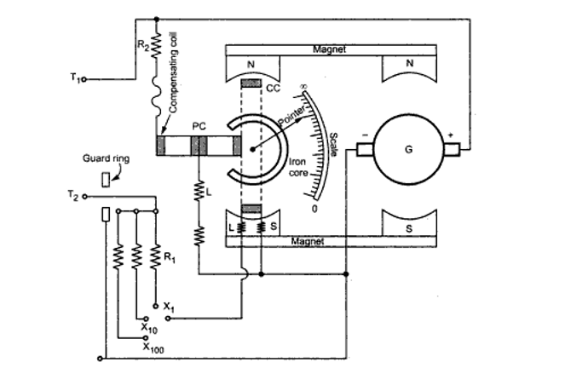

Fig.10. Megger

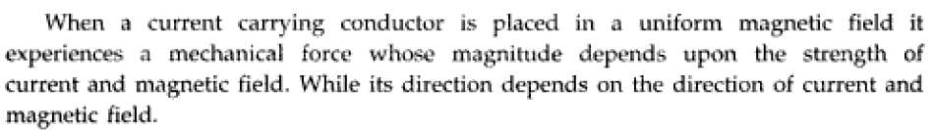

Construction:

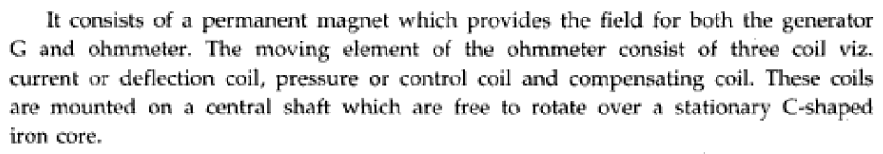

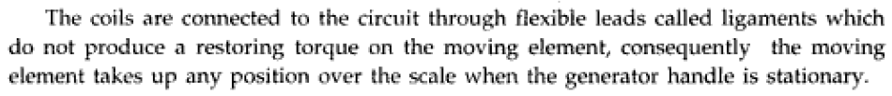

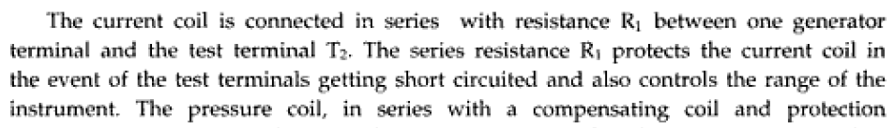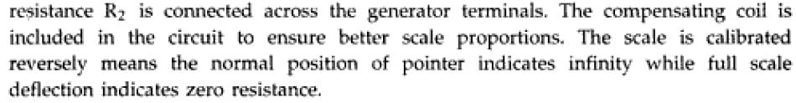

Working:



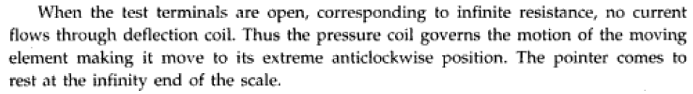

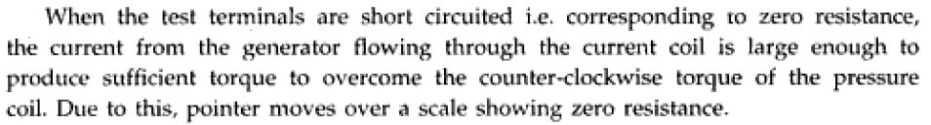

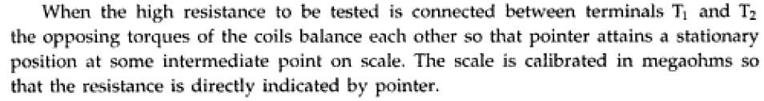

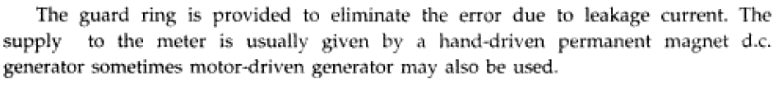

**AC Bridges**

**5.7. Maxwell’s inductance bridge:**

Maxwell’s inductance bridge [measures the value of given inductance](https://myclassbook.wordpress.org/maxwells-inductance-capacitance-bridge/) by comparison with a variable standard self inductance. The circuit diagram of Maxwell’s inductance bridge is shown in figure below.

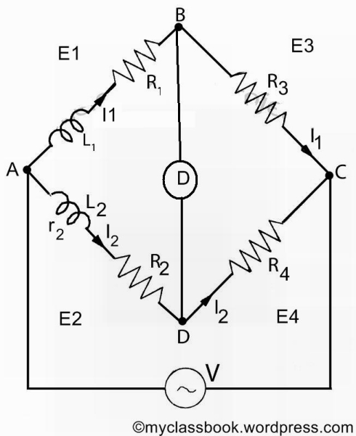

Fig.11

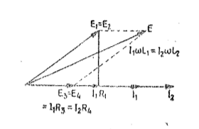

Fig.12.Phasor diagram

Let

L1 = unknown inductance of resistance R1,

L2 = variable inductance of fixed resistance r2,

R2 = variable resistance connected in series with inductor L2,

R3, R4 = known non-inductive resistances.

At balance,

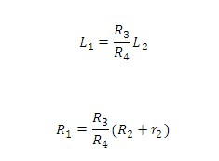

Resistance R3 and R4 are normally a selection of values from 10, 100, 1000 and 10,000O. r2 is decade resistance box. In some cases, an additional known resistance may have to be inserted in series with unknown coil in order to obtain balance.

**5.8.Maxwell’s inductance capacitance bridge:**

In Maxwell’s inductance capacitance bridge the value of inductance is measured by the comparison with standard variable capacitance. The connection for Maxwell’s inductance capacitance bridge is shown in figure below.

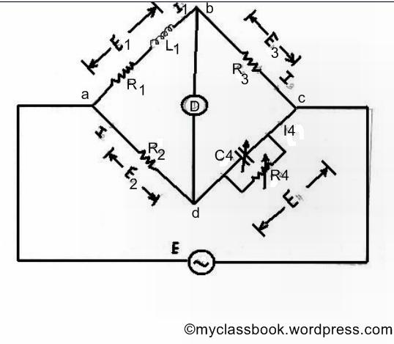

Fig.13

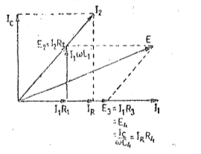

Fig.14.Phasor diagram

Let

L1=unknown inductance,

R1=effective resistance of inductor L1,

R2, R3, R4=known noninductive resistances,

C4=variable standard capacitor.

And writing the equation for balance

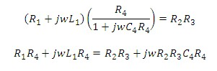

Separating the real and imaginary terms, we have

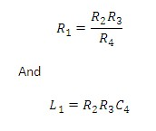

Thus we have two variables R4 and C4 which appear in one of the two balance equations and hence the two equations are independent.

The expression for Q factor

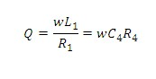

**5.9.Hay’s bridge:**

The Hay’s bridge is modification of the Maxwell’s bridge. The connection diagram of the Hay’s bridge is shown in figure below. This Hay’s bridge uses a resistor in series with a standard capacitor (unlike the Maxwell’s bridge which uses a resistance in parallel with the capacitor).

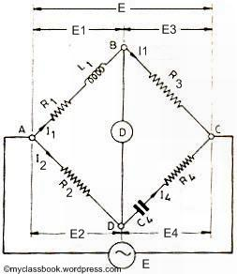

Fig.15

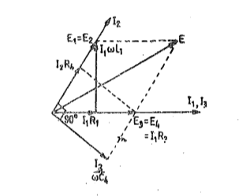

Fig.16.Phasor diagram

Let

L1=unknown resistance having a resistance R1,

R2, R3, R4=known non-inductive resistance,

C4=standard capacitor.

At balance,

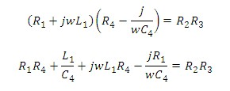

Solving the above two equations we have,

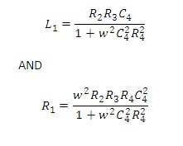

The Q factor of the coil is :

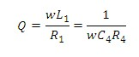

**Advantages of the Hay’s bridge:**

1)      This bridge gives very simple expression for unknown inductance for high Q coils, and is suitable for coils having Q > 10.

2)      This bridge also gives the simple expression for Q factor.

3)      From expression of Q factor it is clear that for high Q factor the value of resistance R4 should be small.

**Disadvantages of Hay’s bridge:**

1)      The Hay’s bridge is suited for measurement of high Q inductors, specially those inductors having Q > 10. For inductors having Q values smaller than 10, the term (1/Q)^2 in the expression for inductance L1 becomes rather important and thus cannot be neglected. Hence this bridge is not suited for measurement of coils having Q less than 10 and for thse applications a Maxwell’s bridge is more suited.

**5.10.Anderson’s Bridge:**

Anderson’s Bridge is the modification of [Maxwell’s inductance-capacitance bridge](http://www.myclassbook.org/maxwells-inductance-capacitance-bridge/). In Anderson’s bridge, a standard capacitor is used for the [measurement](http://en.wikipedia.org/wiki/Measurement) of self-inductance. The main advantage of this method is that it can be used for the wide range of self-inductance measurement.

The following figure shows Anderson’s bridge for the balance conditions.

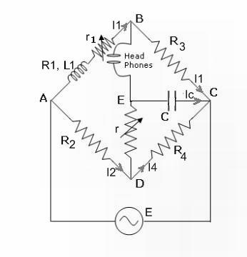

Fig.17

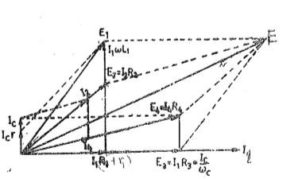

Fig.18. Phasor diagram

Let,

L1 = [Self-inductance](http://en.wikipedia.org/wiki/Inductance) to be measured,

R1 = resistance of self-inductor,

r1 = resistance connected in series with self-inductor,

r, R2, R3, Ra = known non-inductive resistances,

C = fixed standard capacitor.

At balance,

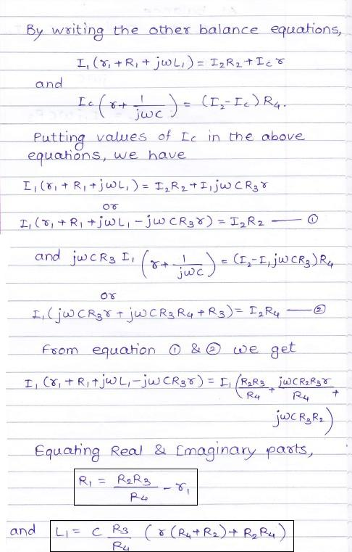

### Advantages of Anderson’s Bridge:

1)      In Anderson’s bridge, it is very easy to obtain the balance point as compared to [Maxwell’s bridge](http://www.myclassbook.org/maxwells-inductance-bridge/).

2)      In this bridge, a fixed standard capacitor is used therefore there is no need of costly variable capacitor.

3)      This method is very accurate for measurement of capacitance in terms of inductance.

### Disadvantages of Anderson’s Bridge:

1) It is more complex as compared with [Maxwell’s inductance bridge](http://myclassbook.org/maxwells-inductance-capacitance-bridge/). It has more parts and hence complex in setting up and manipulate. The balance equations of Anderson’s bridge are quite complex and much more tedious.

2) An additional junction point increases the difficulty of shielding the bridge.

**5.11.Owens Bridge:**

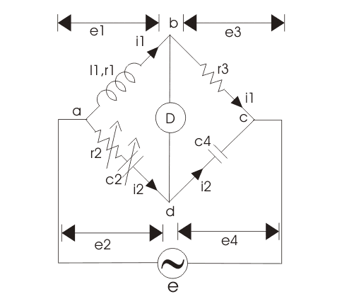

Fig.19.

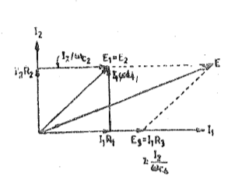

Fig.20.Phasor diagram

The bridge is used for measurement of inductance interms of capacitance.

L1= unknown self inductance

R2=variable non-inductive resistance

R3=fixed non-inductive resistance

C2=variable standard capacitor

C4=fixed standard capacitor

Now at balance point we have the relation from AC bridge theory that must hold good i.e.

Z1Z4=Z2Z3

Putting the value of z1, z2, z3 and in above equation we get



Equating and then separating the real and the imaginary parts we get the expression for l1and r1 as written below

****

Now, there is a need to modify the circuit, in order to calculate the incremental value of inductance. Given below is the modified **circuit of Owen's bridge.**

5.12.De Sauty Bridge:

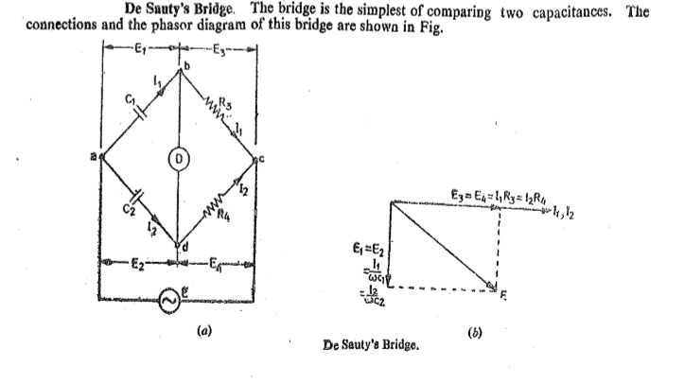

Fig.21

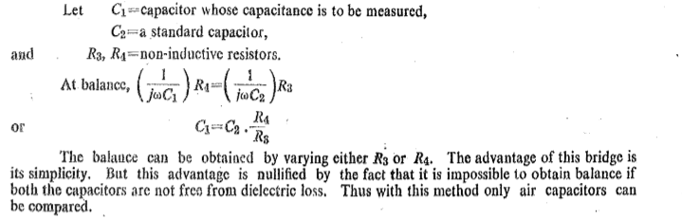

**5.13.Schering Bridge:**

Schering Bridge is one of the very important a.c bridges to measure capacitance, dielectric loss, dissipation factor and relative permittivity of a capacitor.  The Schering Bridge circuit is shown below.

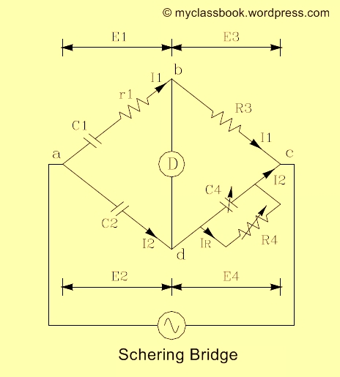

Fig.22

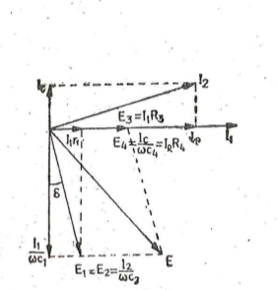

Fig.23 Phasor diagram of Schering Bridge

Let

C1= [capacitor](http://en.wikipedia.org/wiki/Capacitor) whose capacitance is to be determined,

r1 = a [series resistance](http://en.wikipedia.org/wiki/Series_and_parallel_circuits) representing the loss in the capacitor C1

C2 = a standard capacitor

R3 = a non – inductive resistance

C4 = a variable capacitor

R4 = a variable non-inductive resistance in parallel with variable capacitor C4

Now when the Schering Bridge is balanced, then

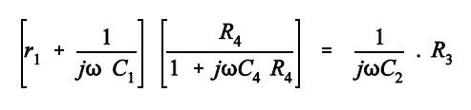

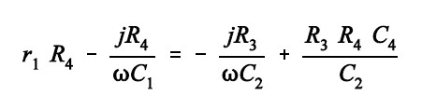

By equating real and imaginary part of the equation we get,

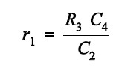

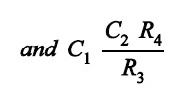

Two independent balance equations are obtained if C4 and R4 are chosen as the variable elements.

The [dissipation factor](http://en.wikipedia.org/wiki/Dissipation_factor) is given by:

6

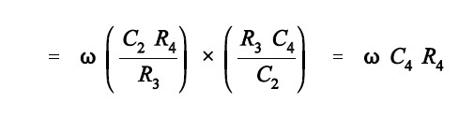

Therefore values of capacitance C1 and its dissipation factor are obtained from the values of bridge elements at balance.

Permanently set up Schering bridges are sometimes arranged so that balancing is done by adjustment of R3 and C4 remaining fixed. Since R3 appears in both the balance equations and therefore there is some difficulty in obtaining balance but it has certain advantages which are explained as follows:

We know that the equation for unknown capacitance is,

In the above equation value of R4 and C2 are fixed therefore the dial resistor R3 may be calibrated to read the capacitance directly.

**Advantages of Schering Bridge:**

1)    The balance equation is independent of frequency.

2)    It is used for measuring the insulating properties of electrical cables and equipments.

**